A

Mini Project Report

On

**“Book Store website”**

Submitted to

**CHHATTISGARH SWAMI VIVEKANAND TECHNICAL UNIVERSITY**

**BHILAI**

in partial fulfillment of the requirement of for the award of degree

Of

**Bachelors of Technology**

In

**COMPUTER SCIENCE AND ENGINEERING**

**By**

**Sneha Yadav**

**DEPARTMENT OF COMPUTER SCIENCE AND ENGINEERING**

**SHRI SHANKARACHARYA TECHNICAL CAMPUS,**

**JUNWANI, BHILAI(C.G.)**

**SESSION 2021-2022**

CERTIFICATE

This is to certify that the thesis report of the project submitted is an outcome of the project entitled **“Book store website”** carried out by **Sneha Yadav** bearing **Roll no. 301403320032** carried out under my guidance and supervision for the award of Degree in B.Tech in **Computer Science and Engineering** of Chhattisgarh Swami Vivekanand Technical university, Bhilai(C.G.),India.

To the best of my knowledge the report.

(1)Embodies the work of the candidates herself/himself.

(2)Fulfills the requirements of the ordinance relating to the B.Tech Degree of the University.And ,

(3)Is up to the desired standard for the purpose of which is submitted.

(Signature of the Class Teacher)

Professor

Computer Science & Egineering Department

**Shri ShankaraCharya Technical Campus**

**Junwani,Bhilai(C.G.)**

The project work as mentioned above is hereby being recommended and forwarded for examination and evaluation.

**(Signature of Head of Department with seal)**

**ACKNOWLEDGEMENT**

I would like to express my special thanks of gratitude to my Mini project teacher “Dr. Abha Choubey Mam” of Computer Science and Engineering department for her valuable guidance and support in completing my project. I am deeply indebted for the valuable discussions at each phase of the project. I consider it my good fortune to have got an opportunity to work with such a wonderful person. I would also like to say thank you to all those who had helped me a lot to complete this project.

INTRODUCTION

Today it is becoming very difficult to maintain records manually. Software system easily does the job of maintaining daily records as well as the transaction according to the user requirements. Only basic knowledge of computers is required for operations. The website consists of all information of books. The proposed system provides lots of facility to the user to store information of the books and it provide information in quick time in a systematic manner. The processing time on the data is very fast.

This project helps the admin to add book with name, price, author name, description and date of publishing in the database it is purely made on HTML, CSS and JavaScript and local storage is used to store data with the help of arrays for sequence storing of data.

Abstract

This project is based on create, read and delete Method.

Create – You can create the data of book in the store (but you need a password for adding a book in the application).

Read – The data of the book can be easily displayed in a tabular form in the main page.

Delete – You can delete the data with the delete button given on the right side of the data.

Technologies Used

HARDWARE REQUIREMENTS -

Processor :i3 Core Processor

RAM : 1 GB

Monitor : Any resolution .

Input Output Console for interaction

Tools –

* Visual studio code
* Live serve – to run the website in localhost

Technologies –

* HTML
* CSS
* JAVASCRIPT

DATABASE –

* LOCAL STORAGE USING JAVASCRIPT

HTML

Hypertext Mark-up Language (HTML) is the standard mark-up language for creating web pages and web applications. With Cascading Style Sheets (CSS) and JavaScript it forms a triad of cornerstone technologies for the World Wide Web. Web browsers receive HTML documents from a webserver or from local storage and render them into multimedia web pages. HTML describes the structure of a web page semantically and originally included cues for the appearance of the document. HTML elements are the building blocks of HTML pages. With HTML constructs, images and other objects, such as interactive forms, may be embedded into the rendered page. It provides a means to create structured documents by denoting structural semantics for text such as headings, paragraphs, lists, links, quotes and other items. HTML elements are delineated by tags, written using angle brackets. Tags such as and introduce content into the page directly. Others such as surround and provide information about document text and may include other tags as sub-elements. Browsers do not display the HTML tags, but use them to interpret the content of the page. HTML can embed programs written in a scripting language such as JavaScript which affect the behaviour and content of web pages. Inclusion of CSS defines the look and layout of content. The World Wide Web Consortium (W3C), maintainer of both the HTML and the CSS standards, has encouraged the use of CSS over explicit presentational HTML since 1997.

CSS

CSS is designed to enable the separation of presentation and content, including layout, colours, and fonts. This separation can improve content accessibility, provide more flexibility and control in the specification of presentation characteristics, enable multiple web pages to share formatting by specifying the relevant CSS in a separate ‘.css’ file, and reduce complexity and repetition in the structural content. Separation of formatting and content also makes it feasible to present the same mark-up page in different styles for different rendering methods, such as on-screen, in print, by voice (via speech-based browser or screen reader), and on Braille-based tactile devices. CSS also has rules for alternate formatting if the content is accessed on a mobile device. The name cascading comes from the specified priority scheme to determine which style rule applies if more than one rule matches a particular element. This cascading priority scheme is predictable.

JAVASCRIPT

JavaScript is a cross-platform, object-oriented scripting language used to make webpages interactive (e.g., having complex animations, clickable buttons, popup menus, etc.). There are also more advanced server side versions of JavaScript such as Node.js, which allow you to add more functionality to a website than downloading files (such as realtime collaboration between multiple computers). Inside a host environment (for example, a web browser), JavaScript can be connected to the objects of its environment to provide programmatic control over them.

JavaScript contains a standard library of objects, such as Array, Date, and Math, and a core set of language elements such as operators, control structures, and statements. Core JavaScript can be extended for a variety of purposes by supplementing it with additional objects.

What is local Storage in JavaScript?

Local Storage is a property that allows JavaScript sites and apps to save key-value pairs in a web browser with no expiration date. This means the data stored in the browser will persist even after the browser window is closed.

In Google Chrome, web storage data is saved in an SQLite file in a subfolder in the user’s profile. The subfolder is located at \AppData\Local\Google\Chrome\User Data\Default\Local Storage on Windows machines and ~/Library/Application Support/Google/Chrome/Default/Local Storage on macOS

Firefox saves storage objects in an SQLite file called webappsstore.sqlite, which is also located in the user’s profile folder.

WORKING WITH THE PROJECT

Interface of the project –

ADD Button to add data of the book –

ADD NEW BOOK BUTTON

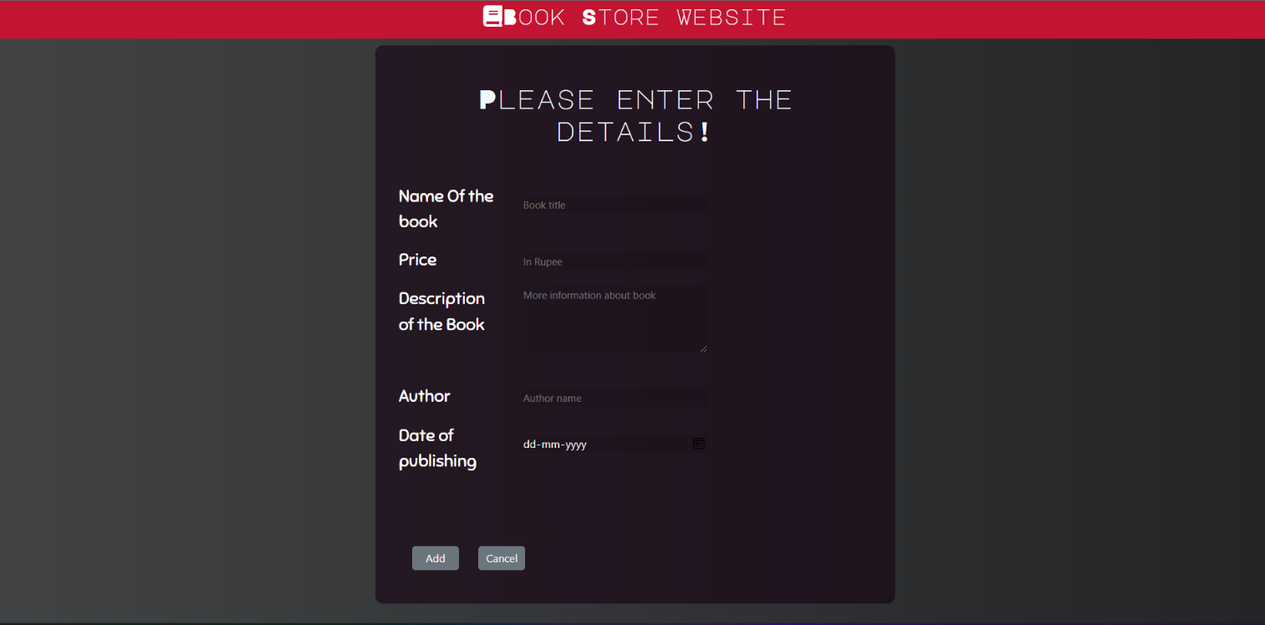Page to add details –

Add data (password needed)

Cancel to go back to the main page

Asking password –

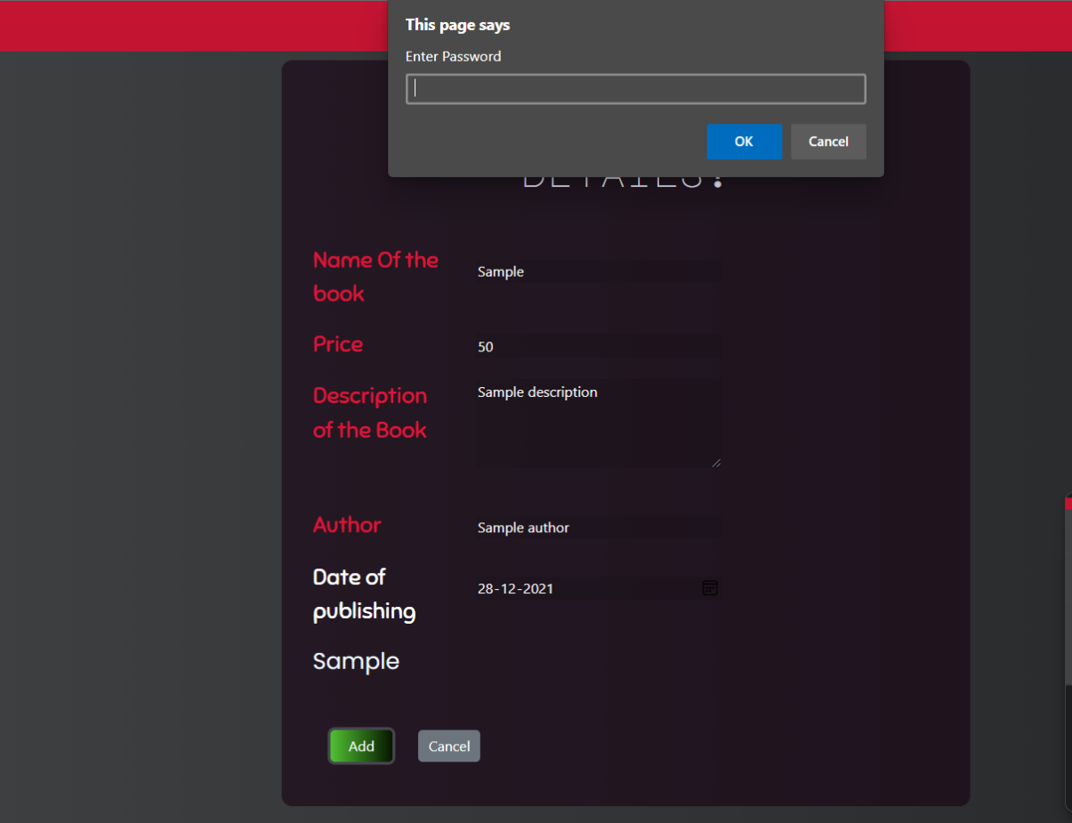

Data in the main page –

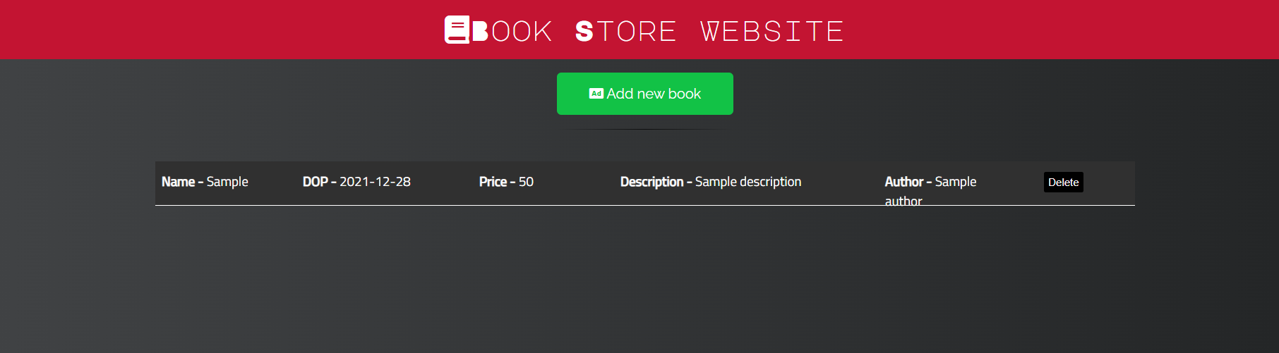

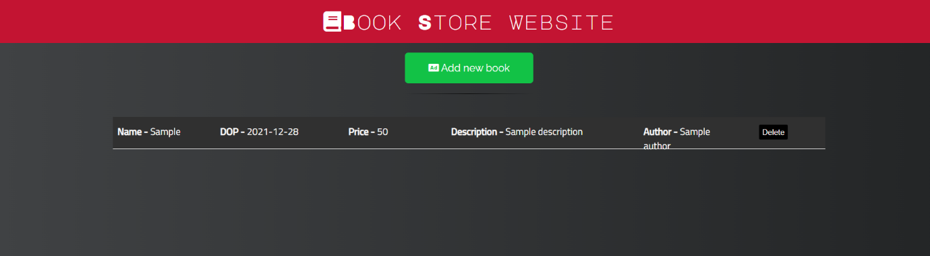Delete Button –

Delete button

Password to delete data –

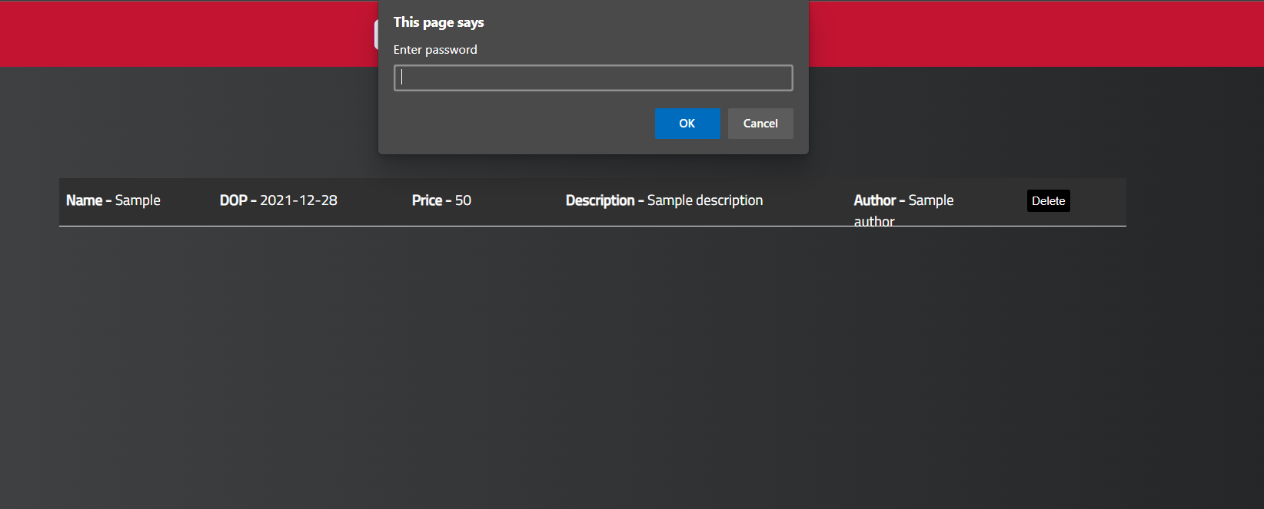

CONCLUSION

To conclude, I have designed an Book store website that is user friendly. The project is based on the requirement specification of the user and the analysis of the existing system, with flexibility for future enhancement. I have implemented the front-end using HTML, CSS and JavaScript and using local storage as database. This project has a user side where he/she can view book and admin can add and delete with the help of password. This project is helpful in managing and displaying data of the book available in a store and user can easily find the book he/she wants through this website.